**10/1/2018**

**Catherine Chen**

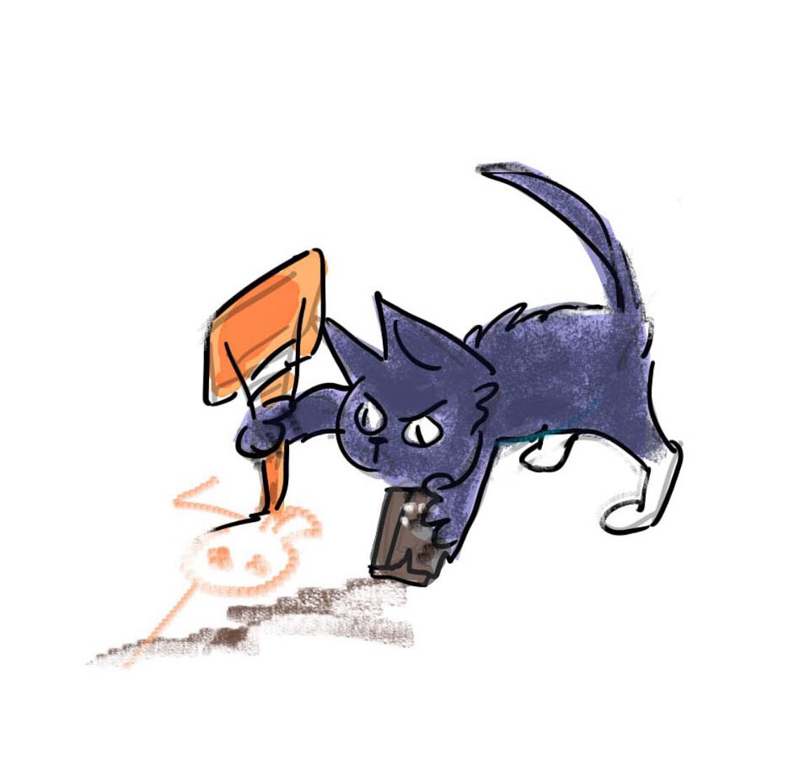

Roadkill

In Los Angeles, the greatest artists are superheroes who fight evil in the Guild of Visual Arts (GOVA) and other schools, such as League of Thespians, the Association of the Creative Arts, etc.

Roadkill, a street cat, wants nothing more than to be part of this celestial human society.

***Roadkill*** is a trash cat and mixed media artist who could turn anything into a masterpiece. She was known to have brought a dead street to life with little more than a few pieces of crayons, and she could breathe life into a whole army of miniature skeletons from just her crayon drawings. Her proudest bragging achievement, true or not, was that she has been to hell and back. However, the Guild still does not let her become one of their members.

She cares a lot that her human competitors hold her in high regard and see her as a superior force to be reckoned with, so she does not handle belittlement very well. Because of that, she is always two steps ahead of everyone. Always assuming the worst, she judges every question first with considerable hesitation. Beneath a spiteful and prideful mask is no softness, but an inspiring and dogmatic stubbornness. While all other cats have nine lives, this one has 99. Killed once and picked by crows, Roadkill is still somehow alive and still endangers herself in stunts.

Although her tongue is fire, Roadkill is the greatest idealist, and nothing makes her more happy than creating something that makes her audience gaze in wonder. No matter how the Guild responds to her, she travels the streets of LA to create dazzling designs to surprise the community around her, fighting crime as a solo artist.

Show details

**Setting:** Modern LA

**Genre:** Superhero + Shonen Anime

**Art style Influences:** Samurai Jack (sharp edges/simplicity) + Tyrus Wong (wild brush strokes)+ Makoto Shinkai (soft blending of background)

**Art Style:** Teen Titans opening (simplicity) + Cowboy Bebop opening (simplicity)

Roadkill Voice Actor Guidelines

**Parameters:**

1. Forward placement, vibrating the lips so that there is a raspy quality.

2. A High pitch, only slightly higher than my normal voice so that I am even smaller.

3. In order to get rid of the American Legato, l’ll use a staccato rhythm, reminiscent of a slight Mexican accent

4. Slight rounded mouth on appropriate vowels, reminiscent of a Mickey Mouse quality

5. Wide exaggerated mouth on appropriate vowels to create a more Vanellope raspier voice, using more space in the mouth.

6. Vanellope von schwätz /Peridot/Yzma cat form

1. Study Vanellope to properly root the voice.
2. Study Peridot for forward placement and raspy quality
3. Study Yzma’s cat voice to free up the voice!

7. Start with Jzargo/Sombra base, think of speaking like a cat, and then add a dice of Peridot on top.

**Dialogue**

* Right now, you are looking at nothing more than Roadkill, the greatest ahrtist alive! Bedazzle! Bedazzle! Pew! Pew! Be dazzled… Whu-eah? You’re confused? That’s wuh…JUST A BRICK!?! - You came early!
* CHALLENGER?!! Ugh.. *YOU* are a challenger? But you’re just a mouse. They didn’t let me into the Guild, so why should they let you?
* Whu-eaht?! But I gave you this! And this! AND THAT! What do you mean I’m not good enough? You went to school for this? Me? Go to school? Why, it’s just play!
* Ugh. Humans! Busy busy busy. Work work work. Don’t know how to be a CHILD!
* Auuhhhhh, I just wish I was human.

**CATCH PHRASE:**

* Tongue sticking out: Whu-eah!
* Laughing: Whu-eah heh heh!
* Oof/ Ahf course/ Sí/ Ah- K. Ah- K/